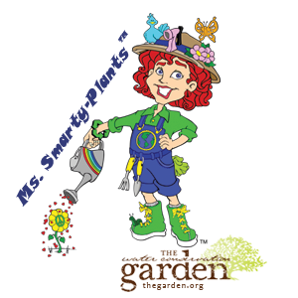
“Nature Tour Guide”
Internship at The Water Conservation Garden

Position:
Nature Tour Guide, Volunteer Intern
Requirements:
Completion or current enrollment in college level courses related to:
Elementary Education, Child Development, Environmental Studies, Recreation, Biology or Sustainability.

Description:
Share your love for the outdoors and teach kids in nature! We are seeking talented individuals to conduct fieldtrip tours as part of Ms. Smarty-Plants™ Fieldtrips at The Water Conservation Garden and assist in classroom related responsibilities. You will work closely with the Education Department to learn teaching techniques from award-winning Education Director, Pam Meisner aka Ms. Smarty-Plants™, and help inspire young people to care for the planet.
The Water Conservation Garden’s Ms. Smarty-Plants™ education program connects students to the natural world through interactive, experiential learning with a focus on preserving our most precious resource; water. In 2014 Ms. Smarty-Plants™ reached over 63,000 children and their families with fun and inspiring conservation education programs. Our ideal candidate is someone who loves spending time outdoors, enjoys being with kids, and has an eagerness to learn in a fast-paced and positive environment.
Duties and Responsibilities
- Train with the Education Specialist to learn tour curriculum and Garden exhibits.
- Lead school tours through The Garden with a focus on experiential learning. Tuesday – Friday (9am-12:00noon)
- Provide support for fieldtrips: planting activity, recycling lesson, setup, prepping materials, classroom cleanup.
- Interact with students, teachers, and parents in a manner that is positive, upbeat, and friendly.

Additional Requirements:
- Strong communication skills. Team-oriented.
- Good report with children.
- Responsible and self-sufficient.
- A good sense of humor and play.
- Ability to oversee classroom behavior (included in training).
Details:
- This internship is unpaid and provides training and career development in a professional environment with the Education Department.
- Minimum four tours per month (12 hours per month). Availability select weekday mornings. Position can start immediately.
- To apply submit application to Education Specialist, Jillian Quint jillian@thegarden.org (619) 660-0614 x16

